Instructions:
- Please download a copy to this document and save it to your personal computer or an online account.
- Read and follow the instructions outlined in “Using Your Checklist)

Please note: This document was last updated in the spring of 2024.

Standard Response Protocols: Situational Awareness Emergency Checklist

Using your Checklist
This checklist is designed to be an abridged version of your school emergency operations plan. This checklist is designed for quick use in the event of an emergency and does not replace an emergency operations plan (EOP) or school safety drills. This checklist is intended to serve as a reference for educators, administrators, staff and does not replace common sense, sound judgement, and prudent actions in response to an emergency situation.
- Since the information provided is generalized, each school or school district should tailor procedures to meet their own specific needs and circumstances.
- Every school staff member should know your own school’s emergency operations policies and procedures, and where written documents are located.
- For best response, present the guide during staff training. This checklist needs to be incorporated in drills and exercises, and should complement your school’s emergency operations plan.
- This checklist incorporates the “I Love U Guys” Standard Response Protocols.
- A copy of this checklist should be placed in every classroom, gym, cafeteria, office, and other locations where students and school staff spend time.

For more information on developing or reviewing your Emergency Operations Plan, please contact your County’s Disaster and Emergency Services Coordinator/Emergency Manager or the State DES Office at (406) 324-4777. Additional information is available on the State DES web site at https://des.mt.gov/
A Federal Emergency Management Agency (FEMA) approved school emergency operations plan is located at the following web address: sampleplan.pdf (fema.gov).

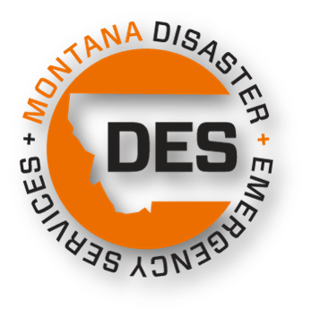

STANDARD RESPONSE PROTOCOLS

Hold
A hold is used to keep the students and school staff in the location they are currently in, whether is in a classroom or outside of the building. This is usually utilized if there is a medical emergency or a fight in a location.

  - Assess the situation - if conditions warrant, Call 911
  - Bring all students into the classroom and sweep the hallway to bring in other students
  - Conduct normal school activities to the fullest extent possible
  - Remain until “the hold is released, all clear” directive is called.

Secure
A secure is used when there is a known threat near the school campus (e.g. safety threat nearby, suspect at large). Secure the school perimeter when a threat is near the school:

  - Assess the situation - if conditions warrant, Call 911
  - Bring all students, staff, and visitors inside the school building
  - Lock all exterior doors and secure windows
  - Do not let anyone enter or exit the secured building, except in an emergency or to allow identified first responders into the building
  - Conduct normal school activities to the fullest extent possible
  - Issue Secure alert to parents and caregivers; assure clear language is used that students are safe

Lockdown
Follow lock-down procedures if a threat is in very close proximity to the school or occurring within the school campus:
- Assess the situation - if conditions warrant, Call 911.
- Issue a lock-down notification, along with procedures, through the most effective means:
  - Announcement over the Public Address (P.A.) system,
  - Sending a messenger to each classroom, or
  - By sounding the established warning signal — utilization of the appropriate code words will minimize panic
- Direct all students, staff and visitors into classrooms with doors that can be locked.
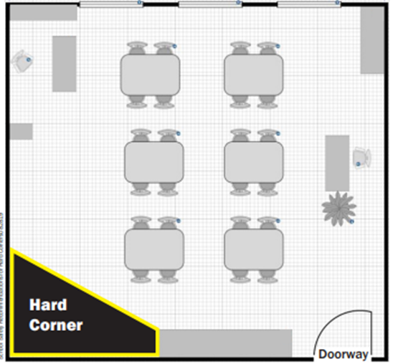
- Lock classroom doors & cover windows accessible by the hallway.
- Cover window(s) in classroom and darken the room; turn off lights and close blinds if you are able to safely and quietly do so.
- Move all people away from windows and doors. If there is concern of an active shooter, move everyone into a hard corner.
- Remain silent and silence cell phones.
- Do not allow anyone outside of the classroom until an administrator unlocks the door and confirms all clear.

Evacuate
Evacuate is called when there is a need to move people from one location to another for safety reason.

  - Assess the situation - if conditions warrant, Call 911
  - The designated authority ___________will issue the evacuation orders.
  - Bring attendance sheet and Go Bag (if available).
  - Direct students and staff to follow specific instructions and route - take alternate routes if primary routes are too dangerous.
  - Assemble outside, allowing room for others to safely convene.
  - Account for all students and staff.
  - If it is necessary, ________________ will coordinate transportation of students and staff to a relocation center.
  - The designated authority ______________notifies the relocation center of their evacuation, the number of students and staff the center can expect to receive and the approximate time they will arrive.

Primary Relocation Center: | Primary Address: | Primary Phone Number:
Alternative Relocation Center: | Alternative Address: | Alternative Phone Number:

Shelter
Sheltering provides refuge for students and staff within the school building(s) during an emergency. Shelters should be located in areas that maximize the safety of inhabitants. Remember, safe areas may change depending on the type of emergency.
  - Assess the situation - if conditions warrant, Call 911
  - Identify safe area(s) in each school building.
  - Create a sheltering kit inventory and place the kit in the sheltering area.
  - When necessary, the designated authority will advise students and staff to assemble in safe areas - all persons should be brought inside the school building.
  - All students and staff need to be accounted for.
  - Close all exterior doors and windows.
  - Turn off any ventilation leading outdoors and that have outside air intakes.
  - Cover up food or any other supplies that could become contaminated.
  - If advised, cover mouth and nose with handkerchief, cloth, paper towels or tissues.
  - All persons must remain in safe areas until notified by the school’s designated authority or emergency responders.

Reunification
During an emergency or disaster the traditional student release procedure is often unsafe and therefore not operable. Initiating a reunification can be a result of anything abnormal at the school that renders it unsafe to stay in, including power outage, weather event, hazmat incident, bomb threat, criminal activity in the area, active violence at the school, etc.
Reunification Procedures
- Establish a parent/guardian check-in location.
- Deliver students to an assembly area beyond the field of vision of parents/ guardians.
- Conduct accountability (attendance) of who is at the assembly area (student and staff). Notify leaders of any missing people.
- Once students are on-site, notify parents/guardians of the reunification location.
- “Greeters” hand parents/guardians a Reunification Card, and help them understand the process.
- The parent/guardian completes the card and brings it to the check-in area.
- Verify Parent/guardian identification and determine if this is the correct person. The card is split at the perforation, and the parent/guardian receives the bottom portion.
- Parent/guardian brings that to an area outside the student assembly area and hands it to a “Reunifier.”
- The “Reunifier” recovers a student from the assembly area and delivers them to the parent/guardian.
- Finally, the “Reunifier” asks student if they want to leave with this person. Reunification complete.
- Pedestrian “flows” should be designed so lines don’t cross as controlled lines of sight allow for an orderly flow, and issues can be handled with less drama and anxiety.
- Medical, notification or investigative contingencies are anticipated.
Do NOT release student to people not listed on the student emergency card.

Basic Response to any Emergency

- Assess the situation and notify Administration of your situation.
- Call 911, if necessary
- Give appropriate Standard Response Protocol during an incident
- Take steps to ensure the safety of students, staff and other individuals in the implementation of incident management protocols.
- Supervise students.
- Take attendance when class relocates to an outside or inside assembly area or evacuates to another location.
- Report missing students to the Administrator/Incident Commander.
- Execute assignments as directed by the Administrator/Incident Commander.
- Obtain first aid services for injured students from the school nurse or person trained in first aid. Arrange for first aid for those unable to be moved.

Active Shooter
Analyze the situation and use your best judgement to Run, Lock, or Fight
Be aware, fire alarms may be triggered by an active shooter. If a fire alarm sounds during an active shooter event, do not evacuate unless you smell smoke or see fire. Continue to use your best judgement to stay safe by running, locking, or fighting.
Standard Response Protocol that may be utilized:
- Hold
- Secure
- Lockdown
- Evacuate

Run: Run only if you know the location of the intruder or can safely escape by exiting the school building or classroom.
- Identify the nearest, safest exit and know your escape route.
- Leave your belongings behind.
- Keep your hands visible.

Lock: Secure yourself in a room if running is not an option. Active shooters do not typically try to enter locked rooms.
- Direct all students, staff, and visitors into rooms with doors that can be locked or barricaded.
- Lock classroom doors. If doors cannot be locked, find ways to barricade the door. No matter what way the door opens, pile things in front of the door and use materials to keep the door from opening.
- Cover window(s) in classroom and darken the room by turning off lights and closing blinds if you can do so safely and quietly.
- Move all persons away from windows and doors and into hard corners.
- Do not allow anyone to leave the room until an all-clear signal is given by the designated authority.

Fight: Fight as a last resort if you are in imminent danger.
- Attempt to overpower the shooter by acting with physical aggression; get help from others to overpower the shooter.
- Use heavy objects you can swing or throw at the shooter.
- Attempt to take control the weapon by grabbing the muzzle.

How to respond when law enforcement arrives:
- Remain calm and follow directions.
- Put down any items in your hands.
- Raise your hands and keep them visible at all times.
- Avoid quick movements and do not approach officers unless directed to do so.
- Avoid pointing or yelling.
- Do not stop and ask an officer for help evacuating.

Animal on school campus
If an animal that poses a threat to safety is on school campus:
Standard Response Protocol that may be utilized:
- Hold
- Secure
- Lockdown

What to do:
- Bring all students, staff and visitors indoors
- Ensure no one leaves the building or other safe locations
- Call your local animal control officer or other authority

Name and number of local animal control of other authority:

__________________________________________________________________________________

Bomb Threat
Gather as much information as you can to determine if the threat is real or a hoax.
Standard Response Protocol that may be utilized:
- Hold
- Secure
- Lockdown
- Evacuate

What to do:
- If the threat is received by telephone, voicemail , e-mail , text message or social media, document as much detail as possible
- If the threat is received by mail, preserve all evidence accompanying the threat
- Notify Administrator
- Call 911 if necessary
- Authorities/Administration will determine the appropriate SRP

Earthquake
Standard Response Protocol that may be utilized:
- Hold
- Evacuate
- Shelter

During an Earthquake:
- Stay calm and stay put- if you are indoors, stay there; if you are outdoors, stay there.
- Drop, Cover & Hold - Know the Drill! *DROP Down to the ground. *Take COVER under a sturdy desk, table, or other piece of furniture - if not possible, take COVER against an interior wall - it is important to COVER your head and neck with your arms - avoid windows, hanging objects, mirrors, tall objects, exterior walls and heavy items on wheels. *If you take cover under a sturdy piece of furniture, HOLD onto it and be prepared to move with it - HOLD the position until the ground stops shaking. Expect aftershocks.
- Expect the electricity to go out, fire alarms to go off, and sprinklers to come on

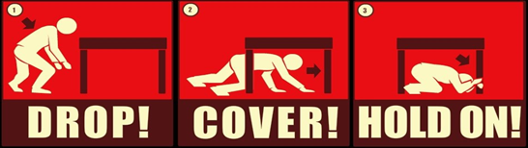

After an Earthquake:
- Stay calm- assure students they will be safe
- Authorities/Administration will determine the appropriate SRP
- Evaluate your immediate situation
- Remove students from hazardous areas
- Account for all students in your area
- Administer first aid if necessary - do not attempt to move seriously injured individual unless they are still in danger
- Do not sure the telephone, light switches, candles, or other open flames unless you are absolutely certain there is no natural gas leaking
- Do no touch electrical power lines or broken electrical equipment
- Be prepared for aftershocks
- Unless you are in immediate danger, do not evacuate unless directed by first responders. Keep in mind, evacuation locations may have been damaged by the earthquake and unsafe to access
- Take your emergency kit or Go bag (if available) with you if it is necessary to evacuate
- Once you reach your alternate destination, account for your students once again - if it was necessary to leave injured students or staff behind, relay that information to the emergency response personnel and provide them the location in which they can be found

Fire
In the event that a fire has been detected, or a gas odor has been detected, take the following actions:
Standard Response Protocol that may be utilized:
- Hold
- Evacuate

What to do:
- Pull the fire alarm
- Activate fire policy and procedure
- Call 911 if necessary
- Notify Administrator
- Authorities/Administration will determine the appropriate SRP
- Account for all students
- The designated authority _________________ will notify staff and students when it has been determined safe to re-enter the evacuated building.

Hazardous Material or Chemical Spill
Standard Response Protocol that may be utilized:
- Hold
- Evacuate
- Shelter

What to do:
- Notify Administrator
- Call 911, if necessary
- Authorities/Administration will determine the appropriate SRP
- Seal off area of leak or spill
- Account for all students

Intruder or Hostage Situation
An intruder is an unauthorized person who enters school property.
Standard Response Protocol that may be utilized:
- Hold
- Secure
- Lockdown
- Evacuate

Intruder:
- Notify the Administrator
- Authorities/Administration will determine the appropriate SRP
- Ask another staff member to accompany you before approaching intruder
- Politely greet intruder and identify yourself
- Ask intruder the purpose of his/her visit
- Inform intruder that all visitors must register at the main office
- If the purpose of their visit is not legitimate, ask intruder to please leave
- Accompany intruder to exit

If the intruder refuses to leave:
- Warn the intruder of consequences for staying on school property without permission or just cause - inform them that your policy requires you to call the police to remove unauthorized individuals
- Walk away from intruder if he/she indicates potential for violence
- Call 911, if necessary

Hostage
- If hostage taker is unaware of your presence, do not intervene
- Call 911 immediately - provide details of the situation and ask for assistance
- Seal off area near hostage scene
- Notify Administrator
- Authorities/Administration will determine the appropriate SRP.
- Give control to police and the other authorities once they arrive
- Keep detailed notes of the event and actions

Missing Student/Person
When a person’s whereabouts cannot be established, and the circumstances suggest they may be in danger.
Standard Response Protocol that may be utilized:
- Hold
- Secure
- Lockdown

What to do:
- Notify Administrator
- Call 911, if necessary
- Authorities/Administration will determine the appropriate SRP.
- Document as many details as you can such as:
  - Details about the students last known where abouts
  - What the student was wearing
  - Last known emotional state of student
  - Take note of any other known details of the students such as medical conditions or disabilities
- Notify the parents/caregivers of the student
- Work with a trusted adult to talk to the friends of the missing student to gather more information. Assure friends and peers of the missing student know the safety of the missing student is the highest priority.

(Suspected Drug) Overdose
Standard Response Protocol that may be utilized:
- Hold
- Secure
- Evacuate

If you suspect someone is experiencing an opioid overdose follow these steps:
- Call 911, if necessary
- Notify Administrator
- Authorities/Administration will determine the appropriate SRP.
- Monitor the person and check for responsiveness.
- Stimulate the person to confirm they are unresponsive: try speaking to the person and pinch their hand or shoulder.
- Check the person’s mouth for any obstructions and remove anything that may be blocking the airway
- If not breathing, administer rescue breaths by tilting the person’s head back and placing your mouth over their mouth. Provide two rescue breaths. Make sure the person’s chest rises with each breath. Continue to give one breath every five seconds. Rescue breaths are the most important part of administering aid. Continue providing rescue breaths until first responders arrive or person regains consciousness.
- Evaluate: Monitor the person and check for responsiveness.
- Administer medication (naloxone) if it is available; continue to provide rescue breaths. It is generally safe to administer Naloxone to anyone, even if they do not have opioids in their system.
- Monitor the person and check for responsiveness. If the person is still unresponsive, continue to provide rescue breaths. If person is still unresponsive after 5 minutes, administer a second dose of medication.
- If the person is conscious or regains consciousness: place them on their left side and keep them warm.

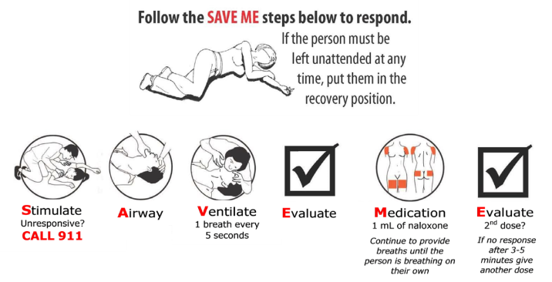

Physical Assaults/Fights
Standard Response Protocols that may be utilized:
- Hold
- Secure
What to do:
- Notify Administration of your situation
- Call 911 if necessary
- Ensure the safety of the students
- Authorities/Administration will determine the appropriate SRP
- Activate Emergency Operations Plan

Severe Storm
Standard Response Protocol that may be utilized:
- Hold
- Secure
- Evacuate
- Shelter

What to do:
- The designated authority _________________ will notify staff and students when it has been determined severe weather is imminent.
- Close windows and blinds
- Account for all students
- Authorities/Administration will determine the appropriate SRP.

Suicide or Suicide Attempt
Standard response protocol that may be utilized:
- Hold
- Secure

Suicide Attempt in School
- Verify information and Call 911.
- Notify school psychologist, counselor, Principal and mental health officials.
- Authorities/Administration will determine the appropriate SRP.
- Principal advises , parent(s) or guardian(s) if a student is suicidal. Try to coregulate the suicidal person.
- Try to isolate the suicidal person from others.
- Stay with suicidal person until professional help arrives -do not leave the person alone.
- Determine method to notify staff, students and parents -hold daily staff debriefings as needed.
- Activate _____________________ to implement post-crisis intervention.*

Suicide Death or Serious Injury
- Verify information and Call 911.
- Authorities/Administration will determine the appropriate SRP.
- Activate crisis response team.
- Notify school staff before the next school day.
- Implement Post Crisis Intervention*

Post- Crisis Intervention:
- Meet with School Counseling Staff and Mental Health Officials to determine level of intervention for staff and students.
- Designate rooms as private counseling areas.
- Escort siblings, friends, and others impacted by the incident, to counselors.
- Resume normal routines as soon as possible while allowing time for grief and meeting the emotional needs of students.
- Assess stress level of staff and recommend counseling as deemed necessary. Note: Support staff who knew the deceased may not be the best equipped to provide emotional support
- Refer media to official spokesperson. Do not let the media interview students.
- Follow up with students and staff.

*Refer to Tool 21 and Tool 22 of the Montana CAST-S for more information

(General) Threat of Violence
Standard Response Protocol that may be utilized:
- Hold
- Secure
- Lockdown
- Evacuate

If a threat of school violence is received by school staff or reported by a student:
- Implement SRP “Secure” unless imminent danger is suspected; if immediate danger is suspected, SRP’s “Lockdown”.
- Call 911, if necessary
- Authorities/Administration will determine the appropriate SRP.
- If the threat is not imminent, work with local authorities to devise the safest plan of action while working to maintain normal school day functions if possible. Refer to your school’s threat assessment procedures.

If the threat is made over the phone or internet, utilize the Phone and Internet Threat Procedures checklist.

School Crisis Team/Safety Team/Emergency Response Team
This is the team that is responsible for creating the Emergency Operations Plan and responding to emergencies.

Telephone Contacts
Contact | Phone Number(s)
Superintendent

Principal

School District Crisis Line

Fire

Sheriff

Police

Highway Patrol

Emergency Medical Service

Local Emergency Planning Committee

Gas Company

Animal Control

County Public Health Department

Children’s Shelter

Youth Services

Child Abuse Line

Runaway Hotline

Domestic Violence Services

American Red Cross

Suicide Hotline: | 988

Telephone Contacts (continued)

Telephone Contacts
Contact | Phone Number(s)

Phone and Internet Threat Checklist
Phone threats:
Standard Response Protocol that may be utilized:
- Hold
- Secure
- Lockdown
- Evacuate

What to do:
- Remain calm.
- Listen and take notes if possible.
- Notify Administrator
- Authorities/Administration will determine the appropriate SRP.
- Do not interrupt the caller.
- Signal someone to get a supervisor or security.
- Try to keep the person on the phone and get as much detail as possible.
- Exact wording of the threat:
________________________________________________________________________________________________________________________________________________
- Did the caller identify him/herself?________________________________________
- Was a specific person or place mentioned in the threat? If so, who/what? _________________________
- Was a specific time and/or date mentioned in the threat?________________________

Caller’s familiarity with the school and/or community | Seemingly high level of knowledge  Seeming low level of knowledge
Caller’s Identity | Male  Female  Adult  Juvenile
Caller’s Speech | Fast  Slow  Clear  Distorted  Stutter  Nasal  Slurred  Lisp
Caller’s Accent | Local  Foreign
Caller’s Manner | Calm | Angry
Caller’s Manner | Rational | Irrational
Caller’s Manner | Coherent | Incoherent
Caller’s Manner | Deliberate (scripted) | Emotional
Caller’s Manner | Righteous | Laughing
Caller’s Voice | Loud | Soft
Caller’s Voice | High Pitch | Deep
Caller’s Voice | Raspy | Intoxicated
Background Noises | Music | Activity
Background Noises | Machines | Traffic
Background Noises | Trains | Airplanes
Background Noises | Animal | Quiet
Background Noises | Other voices

Internet threats:
Try to take a screen shot or record the threat.
- Exact wording of the threat:
_______________________________________________________________________________________________________________________________________________________________________________________________________________________________________________________________
- Did the person identify him/herself?_____________________________________
- Was a specific person or place mentioned in the threat? If so, who/what? ____________
- Was a specific time and/or date mentioned in the threat?_________________________
Person’s familiarity with the school and/or community |  | Seemingly high level of knowledge | Seeming low level of knowledge
Person’s Identity |  | Male | Female
Person’s Identity |  | Adult | Juvenile
Person’s Speech |  | Fast | Slow
Person’s Speech |  | Clear | Distorted
Person’s Speech |  | Stutter | Nasal
Person’s Speech |  | Slurred | Lisp
Person’s Accent |  | Local | Foreign
Person’s Manner |  | Calm | Angry
Person’s Manner |  | Rational | Irrational
Person’s Manner |  | Coherent | Incoherent
Person’s Manner |  | Deliberate | Emotional
Person’s Manner |  | Righteous | Laughing
Person’s Voice |  | Loud | Soft
Person’s Voice |  | High Pitch | Deep
Person’s Voice |  | Raspy | Intoxicated
Background Noises or Images |  | Music | Activity
Background Noises or Images |  | Machines | Traffic
Background Noises or Images |  | Trains | Airplanes
Background Noises or Images |  | Animal | Quiet
Background Noises or Images |  | Other voices | Images:
Notable features about the person |  | Hair color: | Skin color:
Notable features about the person |  | Tattoos: | Clothing:

