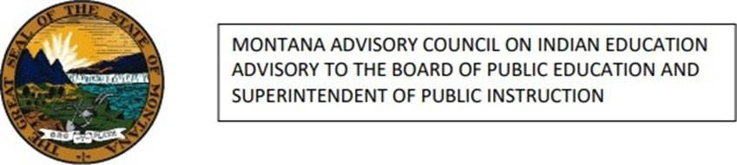

On behalf of the Montana Advisory Council on Indian Education (MACIE), the Montana Office of Public Instruction, and the Montana OPI Indian Education Unit, we affirm our unwavering
support for the rights of Native students across the United States to wear their tribal regalia at public ceremonies, including graduations. Wearing regalia is a deeply significant expression of cultural identity, spiritual tradition, and personal achievement for Indigenous students and their
families. These garments are not “decorations.” Instead, they are often handmade, passed down through generations, and serve as powerful symbols of personal achievement and cultural pride. The ability to wear regalia in spaces of academic recognition honors the sovereignty and dignity of Native nations and acknowledges the resilience and perseverance of Native youth within
educational systems that have not always embraced them.

The passage of the Montana Code Annotated § 2-1-315 stands as a powerful example of how
state-level legislation can protect and uplift Indigenous cultural expression in public institutions.
We encourage other districts, states, and educational leaders to follow this model by adopting inclusive dress code policies that recognize and respect tribal sovereignty and student identity.
Denying Native students the right to wear regalia is not only culturally insensitive but harmful and erases visibility at moments of pride and success. We urge schools and lawmakers across the country to stand in solidarity with Native communities and ensure that every Indigenous student has the right to fully express their heritage at milestone events that celebrate their academic
journey.

Respectfully,

The Montana Advisory Council on Indian Education The Montana Office of Public Instruction
The OPI Indian Education Unit
The Montana Board of Public Education

